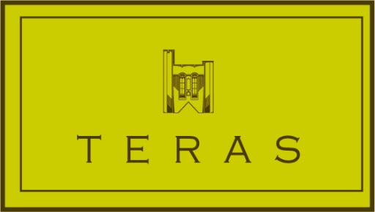
Teras Lounge receives glowing customer feedback
Teras lounge continues to demonstrate its ongoing commitment to the highest standards by achieving excellent customer feedback. The Lounge, which is located in the lower ground floor of the University’s Main Arts building has, over the past 8 months, enabled customers to complete feedback cards that have been used to improve the customer experience.
“The whole team is passionate about delivering the best possible service so we’re delighted by the responses received. 100% of respondents said that our customer service and food was either good or excellent, with 99% stating the overall experience was good or excellent”, said Teras Manager Ingrid Pedersen.
Teras has already been awarded a TripAdvisor certificate of excellence in recognition of its consistently great reviews from Trip Advisor travellers. It is regularly praised by customers for its elegant atmosphere, friendly service and the high quality of its food.
As well as being open between 8.00am and 6pm Monday to Friday, Teras Lounge is also available for private hire during the evenings and weekends.

For more information and bookings visit http://teras.bangor.ac.uk/ , email teras@bangor.ac.uk or call 01248 388686

